Web Engineering   
Assignment#3  
Urooj Ayub  
04456  
BESE-4B

**Link to Public Repository - https://github.com/UroojAyub/phpInterpreter.git**

# Description

Database Credentials used

DB_DATABASE=phpinterpreterlaravel

DB_USERNAME=urooj5

DB_PASSWORD=urooj

Login/Register Page

The first screen on running localhost:8000 it redirects to the login page. The user first has to register and then login. *The first user to ever register will be made the ‘moderator’ while the user registering afterwards will ‘normal users’.* Laravel’s inbuilt make:auth command was used to do the authentication part of this assignment.

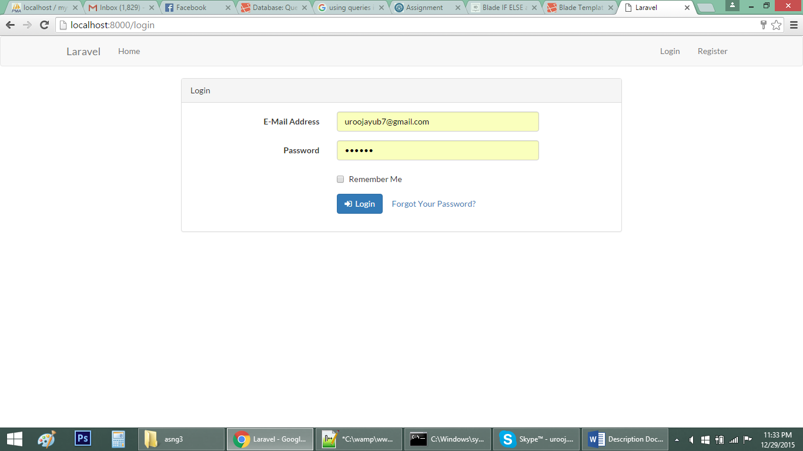

## Interpreter page

After logging in the interpreter page is displayed. It has a text area for entering your code and an iframe displaying the output. *<?php ?> tags must be used else there will be errors*. Run button is used to run the code. This page has two side options 1)Previous Codes

2) Logout

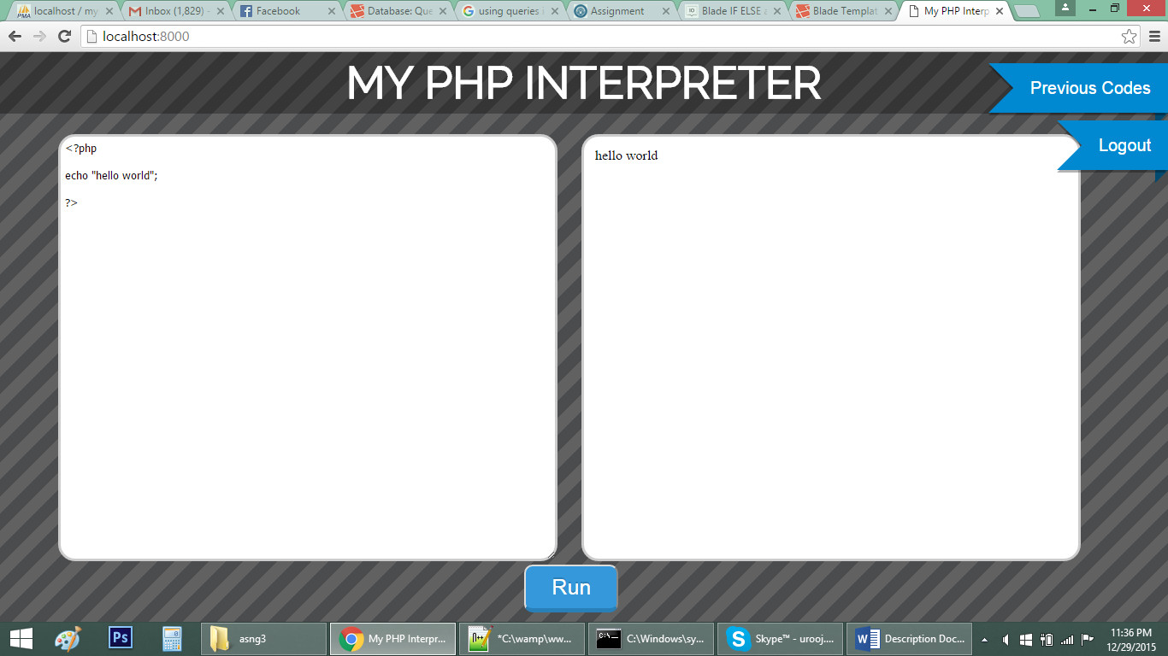

## Previous Codes

This page is used to display the current user’s name, email, role and his previous codes which were interpreted before. If the current user is the moderator previous codes of all other users will also be displayed along with their name and date created. However if current user is a normal user he can only see his own previous codes.

